Jackie Grove

November 15, 2019

IT Foundations 100A

Assignment 6

**Introduction and Setup:**

This assignment is the sixth lesson. We were provided a basic framework and working code and had to convert some of that code into functions. I downloaded the assignment_6_starter.py and put in my the assignment 6 folder I had created on my computer.

For this project I opened the startup file in PyCharms and read through it. I think if I h ad printed it out it may have been easier to figure out what I was to do.

**Coding:**

I used Pycharm and set up an assignment 6. I really struggled with figuring out what we were supposed to do since the TODO parts weren’t clear to me. In addition, the code worked! After reviewing the forums and videos I pieced it together. I was able to piece together the first step (show current items in list). Setting up the class and the calling of the variables took up most of the time. Once I was able to get the first couple sections figured out the others were easier in terms of understanding what was required. I continued to create a function for each block of text and work out how to get variables in and out of the individual functions.

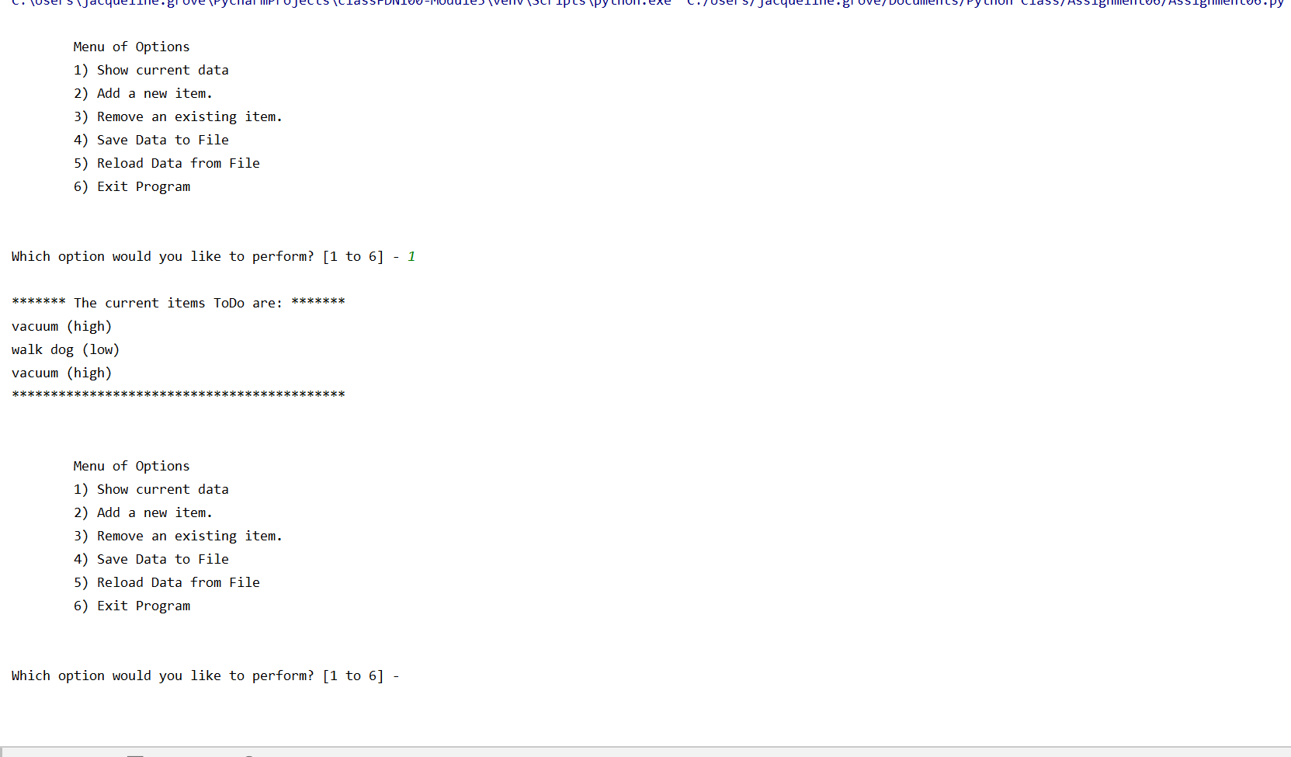

**Saving the Script:**  
I used the Pycharm console to create a new file called Assignment 6. I saved it into my assignment6 folder along with a text file called todofile.txt

**Summary:**

After watching the week’s lesson I read the sixth chapter of the textbook. I also spent some time looking at the referenced videos and other online materials. Using that knowledge I was able create a series of functions from provided code.